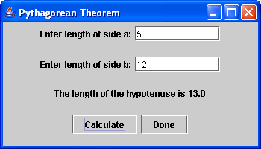
Exercise 1:

The Pythagorean Theorem states that a² + b² = c² where a and b are the lengths of two sides of a right triangle and c is the length of the side of the triangle opposite the right angle (the hypotenuse). Create a Pythagorean Theorem application that asks the user for the lengths of sides a and b, and then calculates the length of the hypotenuse.

Hints:
➢ Remember: a² is just a*a.
➢ 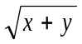 is written Math.sqrt(x+y) in Java
➢ You can get a number from the text box using:
double a = Double.parseDouble (text1.getText());
➢ Or better yet:
double a;
try
{
a = Double.parseDouble (text1.getText());
}
catch (NumberFormatException ex)
{
a = 0; // just make it zero for simplicity
}
- The Done button can do the following:
this.dispose();
System.exit (0);

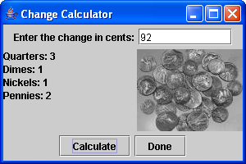
Exercise 2:

Create an application that will calculate and display the minimum number of coins needed to make the amount of change entered by the user. The change can be made up of quarters, dimes, nickels and pennies. Assume that the amount of change is less than $1.00.

Hints:
➢ Think about what order you would calculate the change.
➢ You can create a label with a picture in it like:
ImageIcon icon = new ImageIcon ("coins.jpg");
JLabel label2 = new JLabel (icon);
➢ You can get int values in a similar way to double values:
int a = Integer.parseInt(text1.getText());

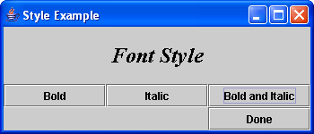
Exercise 3:

Create an application that demonstrates changing the font style of a label. The label should be centred and contain the words “Font Style” in font size 24. Three buttons will then change the style of the font to bold only, italics only or bold and italic.

Hints:
➢ You will have to change the Font of the label with something like:
label1.setFont (new Font ("Times New Roman",
Font.BOLD | Font.ITALIC, 24));

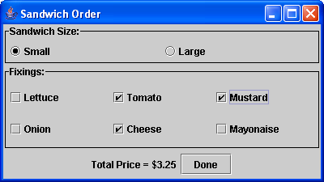
Exercise 4:

Create a Sandwich Order application that allows the user to calculate the price of different sandwiches. The base cost of a small sandwich is $2.50 and the base cost of a large is $4.00. Mustard and mayonnaise are free, lettuce and onion are an extra $0.10 each, tomato is $0.25 extra and cheese is $0.50 extra. The default should be a small sandwich with no toppings. The program should update the total price as the changes are made.

Hints:
➢ You can put a border on a component with something like:
TitledBorder border = new TitledBorder (
new LineBorder (Color.black), "Sandwich Size:");
north.setBorder (border);

(you will have to import javax.swing.border.* first)

